**Use Cases:**

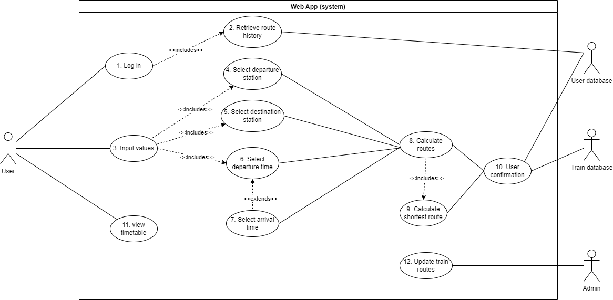

* **Login –** A user has unique details to login. Once they log in the system will find previous route history to make suggestions on stations to travel between.
* **Input values –** This is when a user chooses specific stations and times. It includes selecting the departure station and selecting the destination station. The user must also select a departure time and has the option of selecting an arrival time.
* **Calculate routes –** The inputted stations and times are then used to find all routes between the stations.
* **Calculate shortest route –** An algorithm then calculates the shortest of these routes which coincides with the given time(s).
* **Confirm route –** The user must then confirm the available route so that it can be added to their route history for future travelling.
* **View timetable –** The user can also just simply view the times that trains arrive at specific stations.
* **Update train routes –** Admin can update train routes or schedules whenever these change. These updates must reflect in the database afterwards.

**Typical course of events**

|  |  |
| --- | --- |
| **Actor Action** | **System Response** |
| 1. User logs in | 1. Retrieve unique route history and suggest stations |
| 1. User chooses departure station | 1. Verifies station |
| 1. User chooses destination station | 1. Verifies station |
| 1. User chooses departure time (and possibly arrival time) | 1. Finds all routes that fit the given inputs 2. Calculate and return shortest route |
| 1. Confirm shortest path | 1. Add route to history |

**Alternative flows**

|  |  |
| --- | --- |
| **Actor Action** | **System Response** |
| 1. User chooses invalid departure station. | Returns error of invalid station and prompts valid station (back to step 1) |
| 1. User chooses times which are unrealistic/unachievable | Returns error of unachievable times and prompts user for new times (back to step 6) |
| 1. User chooses invalid destination station | Returns error of invalid station and prompts valid station (back to step 4) |
|  |  |